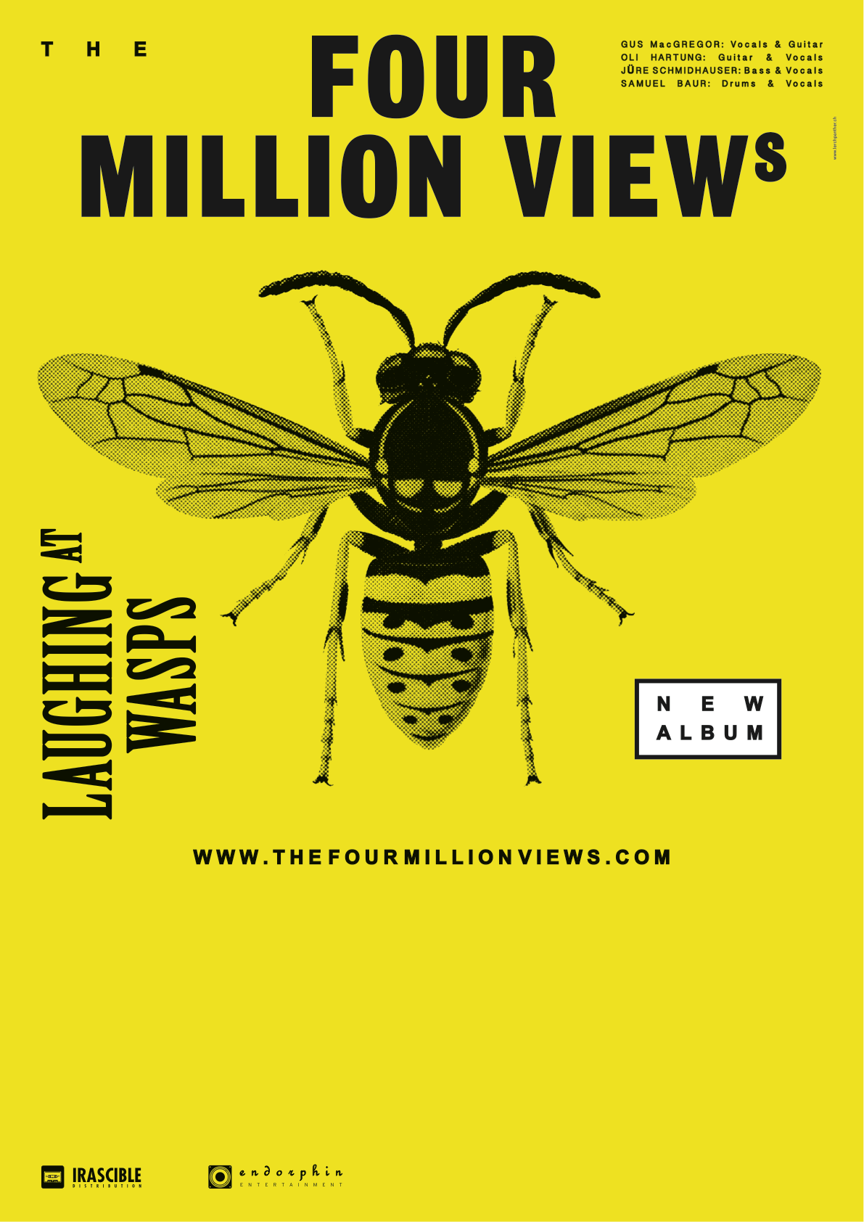

00. NOVEMBER 2014

ALBUM TAUFE

LOCATION, CITY